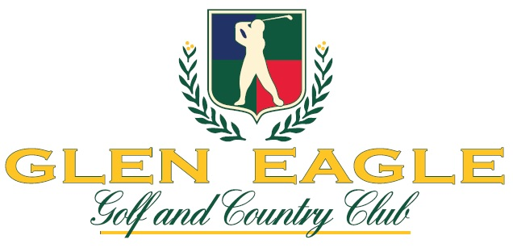
General Manager/COO Candidate Supplemental Questionnaire
This form must be submitted along with your resume or CV to board@gleneaglecountryclub.com
Your Name:
Current Club:
Annual budget
Annual Golf revenue
Annual F&B revenue
Number of employees (FTEs)
Number of residences
Number of golf holes
Annual rounds of golf
General: Why are you interested in the GM/COO position at Glen Eagle Golf & Country Club?
Current or last position: Describe your recent experience including the scope of oversight and leadership, number of direct reports, total budget and key responsibilities.
Strategic planning: Where do you see the greatest opportunities for growth in a private country club? What trends in the hospitality or club industry do you think are most important to prepare for? How do you attract and retain younger members while still respecting traditions valued by long-time members?
Leadership and organization: How would you describe your management style? Describe processes you have implemented in the mentoring and development of your management team and staff, and the results.
Financial planning: Describe each step in your annual budget process from start to finish. How does it begin, who is involved in each sequential step, what is the timing, etc.
How do you motivate and manage a diverse team across departments like golf, tennis, F&B, and facilities to remain within budget while continuously improving the member experience?
What’s the biggest personnel challenge you’ve faced and how did you resolve it? How do you build a culture of service and accountability while retaining staff?
Describe a time when you improved profitability or cut costs without lowering service quality. What strategies do you use to maximize revenue from golf, F&B, special events or other amenities?
Food and Beverage: Describe in detail your F&B background and experience. What are some changes you have made to F&B operations that have had a positive impact on member experience or the budget?
Golf: Describe in detail your Golf background and experience. What are some changes you have made to golf operations that have had a positive impact on member experience or the budget.
Performance: What tools and metrics do you use to evaluate the performance of your staff and yourself? How frequently do you measure and evaluate performance?
Meeting expectations: Country clubs are member-driven. How do you balance member expectations with operational realities? How do you gather and act on member feedback? Provide an example of how you improved the member experience.
Board interaction: How do you balance governance input with operational independence? What do you believe are the keys to maintaining a strong GM–Board partnership? What are the characteristics of a successful Board that would work best with your management style?
Capital and Infrastructure: Describe your capital project experience. What large infrastructure projects have you been responsible for? Describe the process you followed and the results.
Programming: What’s the most successful event or initiative you’ve created or overseen at a club? Describe ways in which you work with staff to ensure consistent execution across weddings, golf outings, and member events.
Interpersonal Skills: Describe one of the most challenging issues you have ever had with a member and how you addressed the situation. What was the outcome?
Continuing Education: Describe any certifications, courses or degrees have you completed in the past 5 years or are you currently working toward. How frequently do you attend industry association conferences or meetings and which ones (CMAA, PGA, etc)?
Problem solving and decision-making: If selected for this position, describe the most significant things you would seek to accomplish in your first 100 days and also in your first year.
In the next 12 months, our club will vote on whether to make major renovations to our infrastructure. Describe any experience you have in this area with respect to marketing, communications, planning, design, process or project management, construction management, interim facilities, etc.
Describe a signature event you created or improved that enhanced the club’s reputation or the member experience. What is your approach to blending athletic amenities (golf, tennis, fitness) with social programming to create a full lifestyle experience that engages with the most members possible?
Optional information: Use the space below to share anything else we should know about you that was not covered in your resume or CV, or this document that would make you an excellent fit for this position

Thank you for taking the time to complete the supplemental questionnaire. Please submit this document along with your resume or CV to board@gleneaglecountryclub.com.

